**Pneumonia Detection from Chest X-Rays**

This project focuses on Pneumonia Detection using CNNs to classify chest X-ray images as pneumonia-positive or negative. The tasks include preprocessing the Chest X-Ray Images Dataset (resizing and normalizing images), applying data augmentation techniques, and fine-tuning pre-trained models like MobileNet or InceptionV3. The model's performance is evaluated using sensitivity, specificity, and ROC-AUC scores, with a comparison of results on augmented and non-augmented datasets.

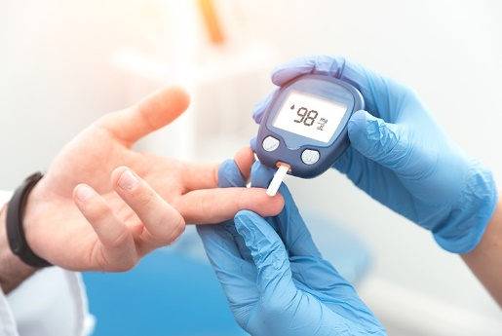

**Objectives:**

1. Develop a deep learning model to classify chest X-ray images as pneumonia-positive or negative.
2. Preprocess and augment the dataset to improve model generalization.
3. Implement or fine-tune pre-trained CNN models like MobileNet or InceptionV3 for accurate classification.
4. Evaluate the model's performance using metrics such as sensitivity, specificity, and ROC-AUC.

**Insights:**

1. **Data Augmentation Impact:** Enhanced the model's ability to generalize across diverse X-ray images by applying random cropping, rotation, and histogram equalization.
2. **Transfer Learning Success:** Pre-trained CNNs like MobileNet and InceptionV3 demonstrated superior performance after fine-tuning for pneumonia detection.
3. **Performance Metrics:** Sensitivity and specificity provided critical insights into model accuracy, with ROC-AUC scores reflecting its ability to distinguish between pneumonia-positive and negative cases.
4. **Augmented vs. Non-Augmented Data:** Models trained on augmented data showed improved robustness and higher evaluation scores compared to those trained on non-augmented datasets.

**Dataset:**

Dataset used from Kaggle(<https://www.kaggle.com/datasets/paultimothymooney/chest-xray-pneumonia>)

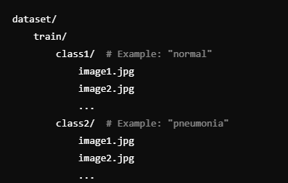 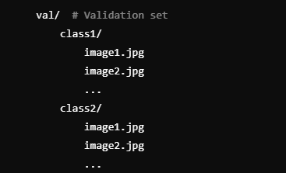 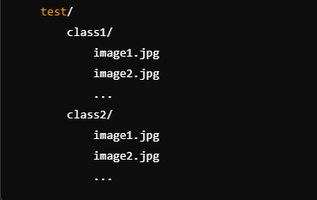

**Libraries**

**What libraries that we used in this project actually.**

* Pandas Ipython
* Numpy
* Sklearn
* Matplotlib
* Seaborn
* openCv

**Framwork:**

* TensorFlow
* Keras

**Visulise :**

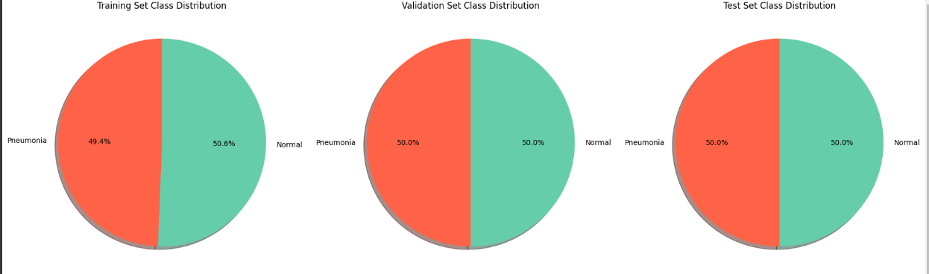

**Evaluate the model**

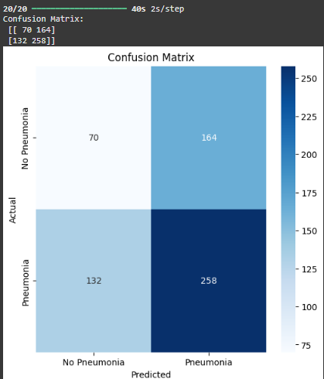 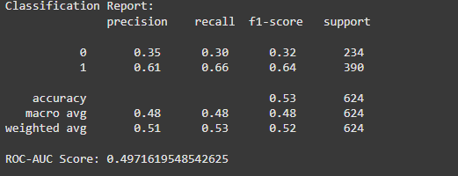

**Environment :**

Google Colab

**Project Access**

**Google colab link (**[**https://colab.research.google.com/drive/15GnKDrSq1utwKW4vJusp7eUp82GP5YxY?usp=sharing**](https://colab.research.google.com/drive/15GnKDrSq1utwKW4vJusp7eUp82GP5YxY?usp=sharing)**)**

**Testing Result :**

